**SYST16023 MS PowerShell Scripting**

**LAB 3: GIT**

**SUBMITTED BY:**

**Name: Manav Tandon**

**Student ID: 991701907**

**Submission Date: 21 September, 2024.**

**Requirements:**

**1. Visual Studio Code (VS Code)**

**2. Git**

**Setting up Environment:**

PowerShell extension:

I want to create GIT repository file in C:\Users\rocky\OneDrive\Desktop\Semester 4\Powershell Scripting\Week3\Lab3

cd C:\Users\rocky\OneDrive\Desktop\Semester 4\Powershell Scripting\Week3\Lab3

**Initialize the Repository:**

**git init**

Add Git to PATH:

[Environment]::SetEnvironmentVariable("Path", $env:Path + ";C:\Program Files\Git\bin", [EnvironmentVariableTarget]::User)

Verify:

$env:Path -split ';'

Git version:

git –version

**Create a new file and add initial content.**

"Initial content" | Out-File -FilePath "C:\Users\rocky\OneDrive\Desktop\Semester 4\Powershell Scripting\Week3\Lab3\example.txt"

**Check the content:**

Get-Content .\example.txt

**Stage and commit the new file:**

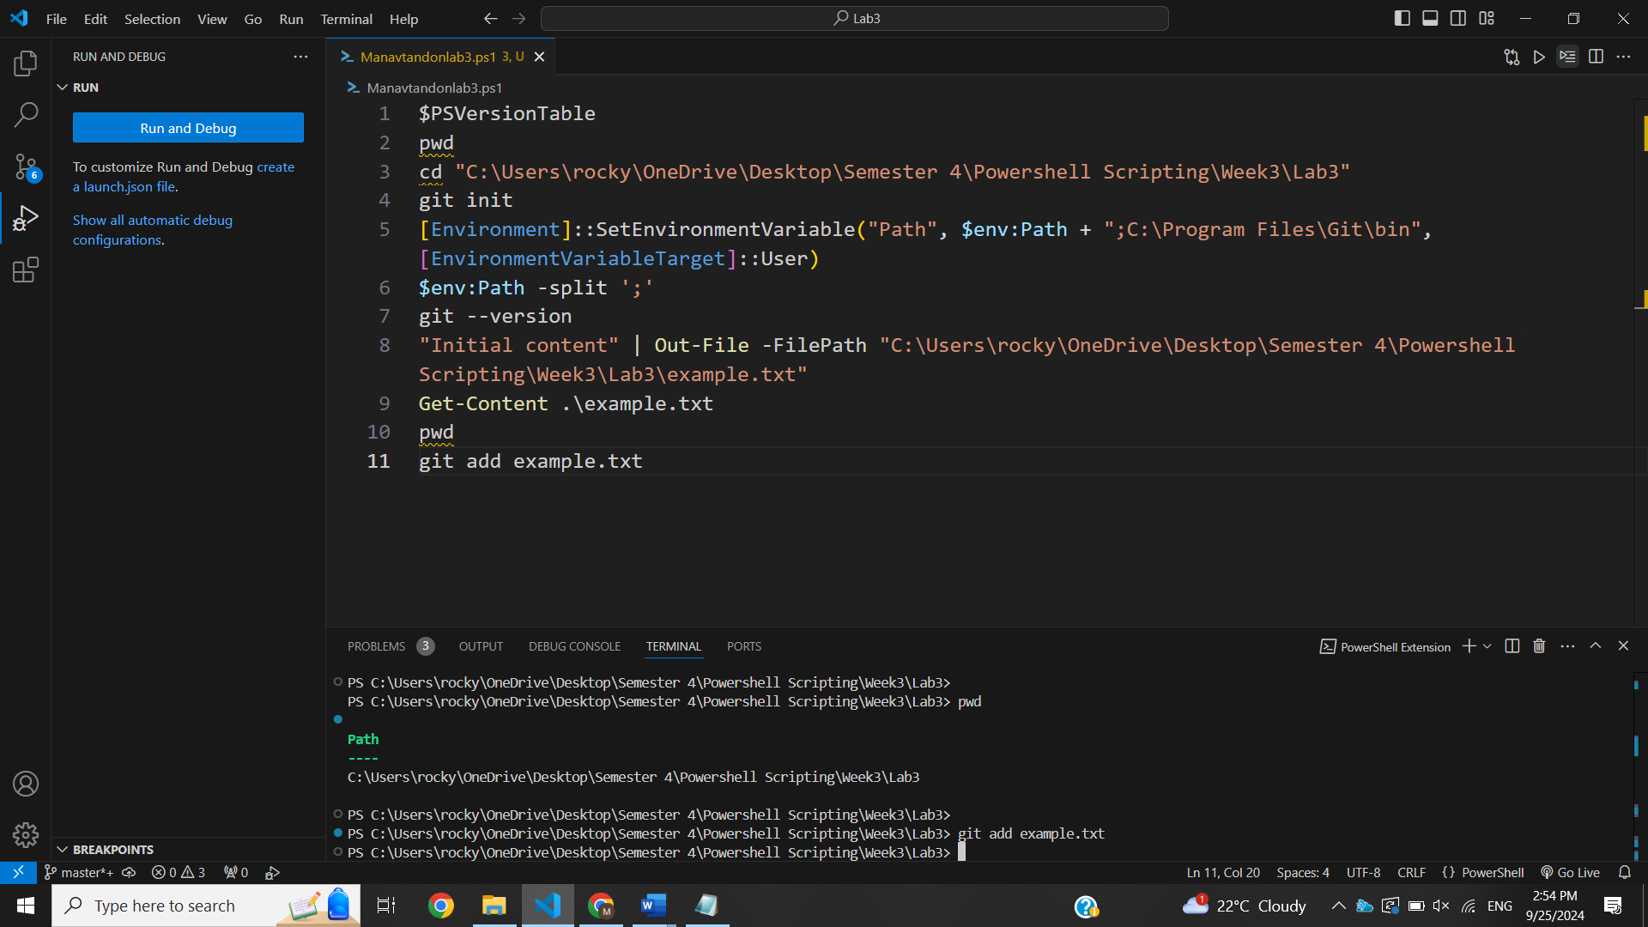

git add example.txt

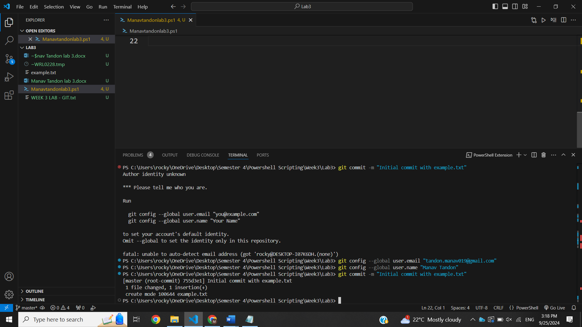

git commit -m "Initial commit with example.txt"

git config –global user.email “[tandon.manav019@gmail.com](mailto:tandon.manav019@gmail.com)”

git config –global user.name “Manav Tandon”

**Modify the file content**

"Modified content" | Out-File -FilePath "C:\Users\rocky\OneDrive\Desktop\Semester 4\Powershell Scripting\Week3\Lab3\example.txt"

Get-Content .\example.txt

**Stage the changes**

git add example.txt

**Amend the previous commit without changing the commit message:**

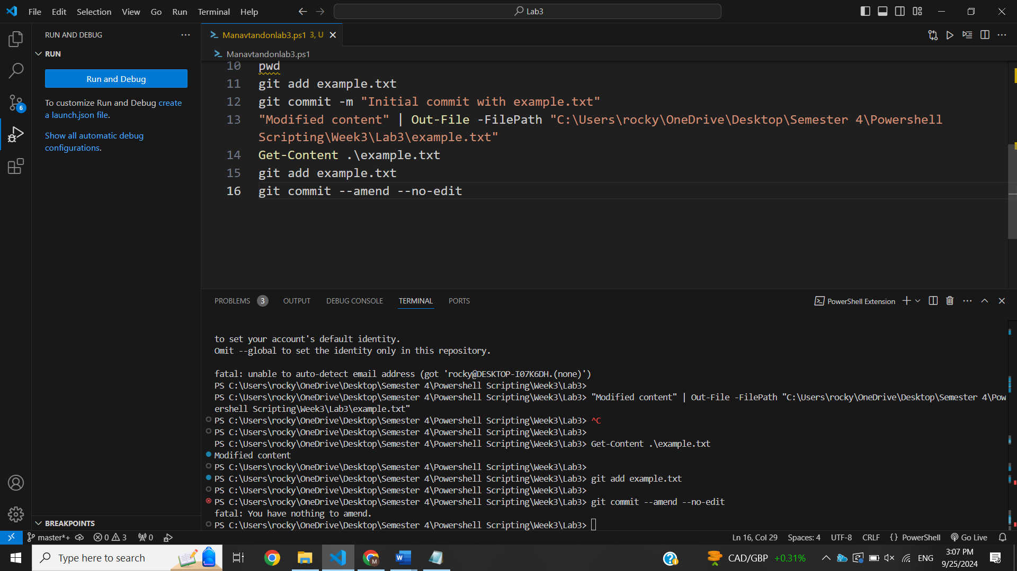

**Changing a Commit Message:**